**Installations of kops :**

* First of all create a EC2 server in ubuntu in t2micro Edit configuration .
* Switch to root user by the command sudo su –
* and update it using command apt update -y
* Now install Docker using commands and start it
* Give excussion permission using command chmod
* Install kubectl using commands
* Now go to iam user and create a access key and secret key
* Now type aws configuration and paste access key and secret key
* 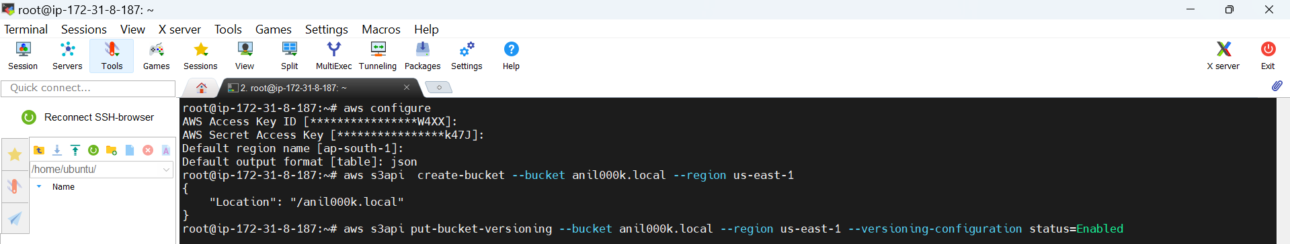
* **Install kops using commands :**
* Curl-Lo <https://github.com/kubernetes/kops/releases/download/v1.25.0/kops-linux-amd64>
* Give excussion permission and move in folder
* Now go inside of the bashrc edit path
* And create s3 bucket with region using commands
* 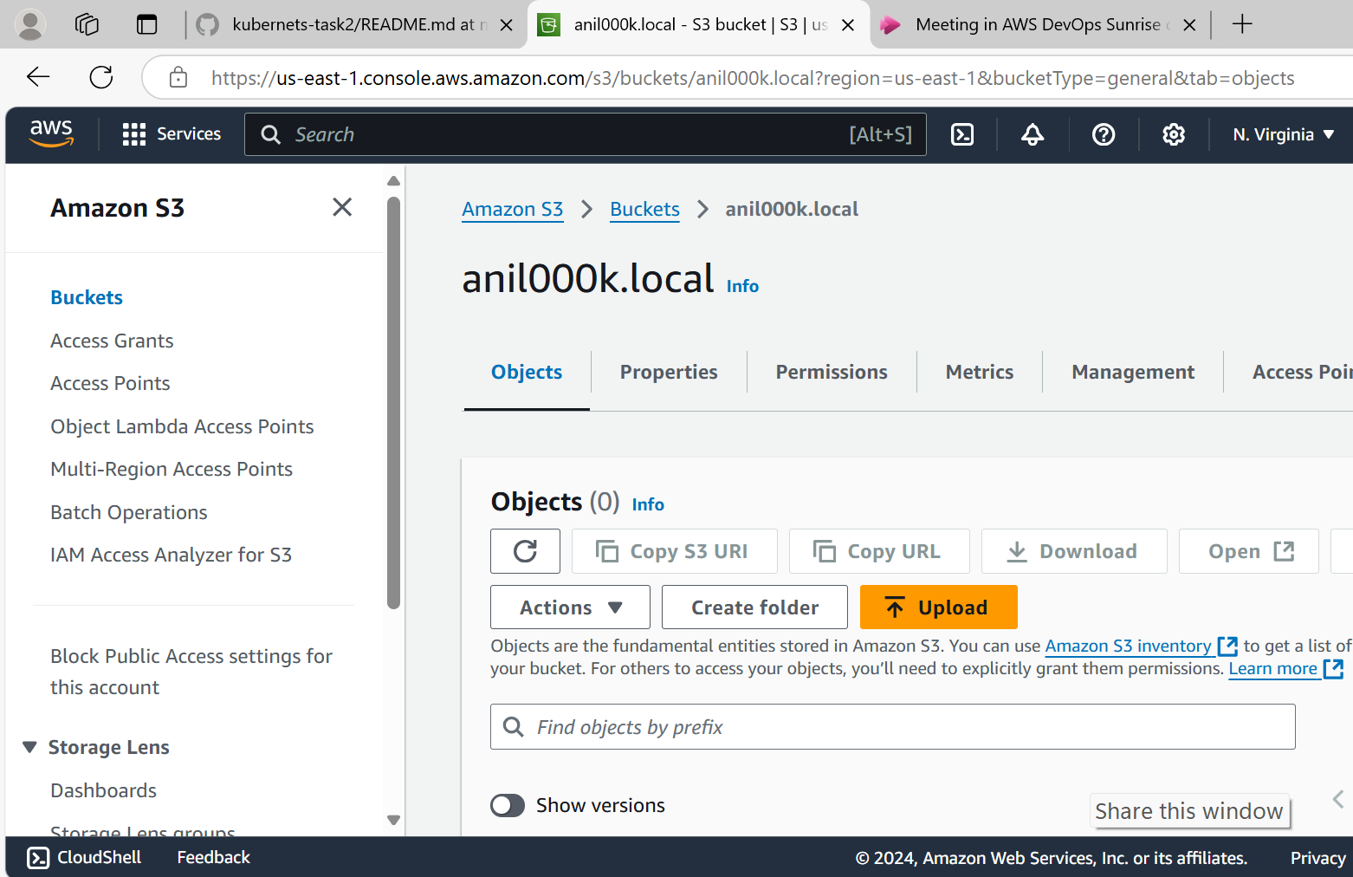
* Now put versioning with status of enabled
* And export it using store s3
* Create a cluster with name and using s3 with regions and using storage
* 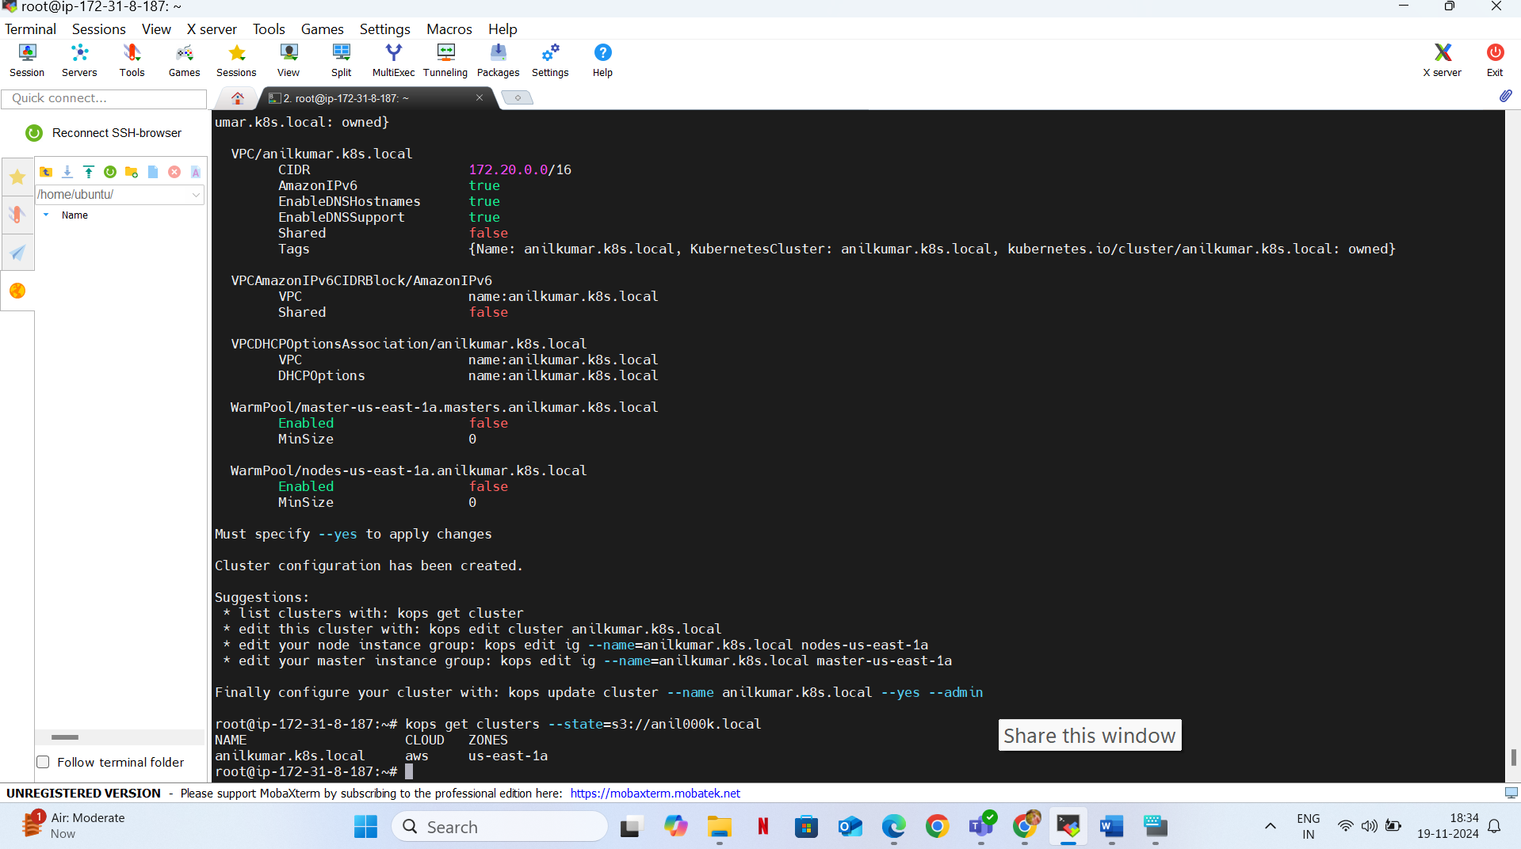
* Give ssh keygen   
  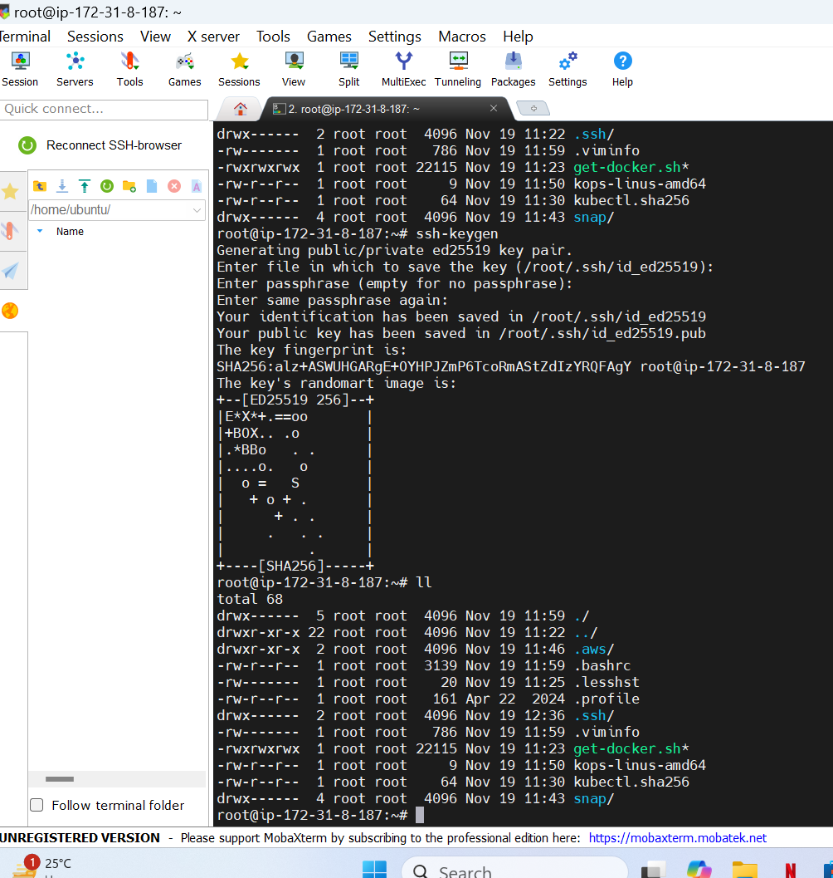
* And we can edit the cluster using with the help of commands
* 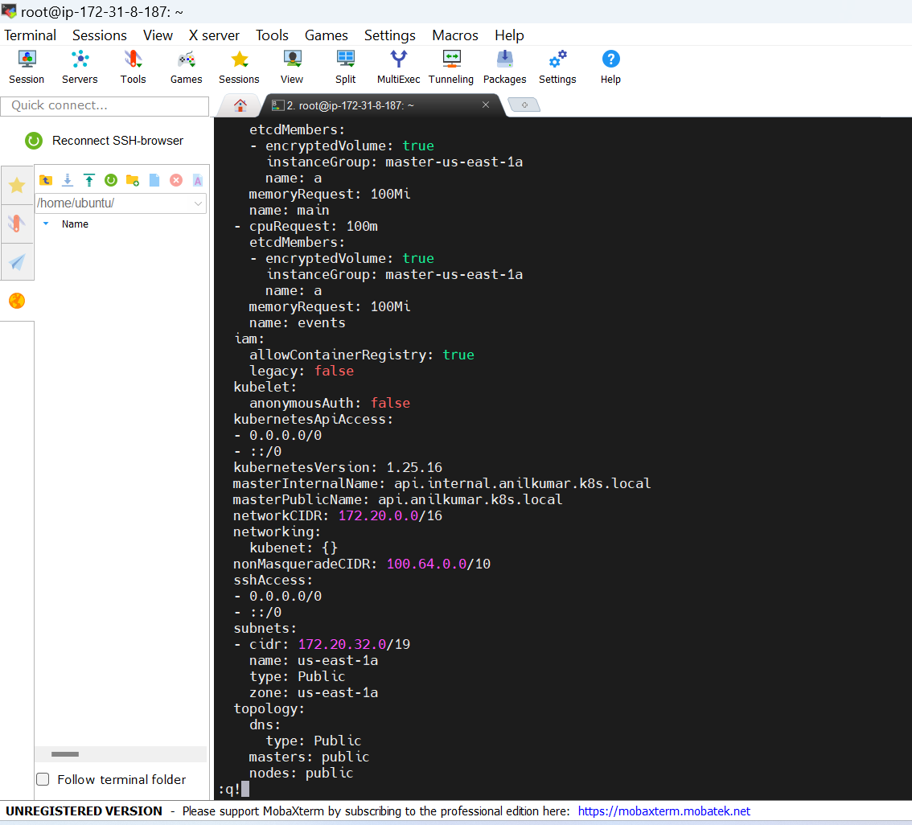
* Later update it using update cluster commands
* Results:
* 